PRAKTIKUM BASIS DATA

MODUL 3
Scripting SQL Basic


Oleh:

Fatikhah Sukma Arti 103122400019

PROGRAM STUDI S1 REKAYASA PERANGKAT LUNAK
DIREKTORAT KAMPUS PURWOKERTO
UNIVERSITAS TELKOM
2026
TP

- Buatlah sebuah table mahasiswa dengan atribut: id, nama, tempat lahir, tanggal lahir, nomor hp, email, tinggi badan, berat badan.
CREATE TABLE mahasiswa (
id NUMBER PRIMARY KEY,
nama VARCHAR2(50),
tempat_lahir VARCHAR2(50),
tanggal_lahir DATE,
nomor_hp VARCHAR2(15),
email VARCHAR2(50),
tinggi_badan NUMBER,
berat_badan NUMBER
);

Screenshots :
- Lakukan insert data pada table nomor 1 sebanyak 15 rows.
INSERT INTO mahasiswa VALUES (1,'Yuji Itadori','Sendai',DATE '2003-03-20','081234567001','yuji@gmail.com',173,65);
INSERT INTO mahasiswa VALUES (2,'Megumi Fushiguro','Tokyo',DATE '2002-12-22','081234567002','megumi@gmail.com',175,63);
INSERT INTO mahasiswa VALUES (3,'Nobara Kugisaki','Morioka',DATE '2003-08-07','081234567003','nobara@gmail.com',160,50);
INSERT INTO mahasiswa VALUES (4,'Satoru Gojo','Tokyo',DATE '1995-12-07','081234567004','gojo@gmail.com',190,78);
INSERT INTO mahasiswa VALUES (5,'Maki Zenin','Kyoto',DATE '2002-01-20','081234567005','maki@gmail.com',170,60);
INSERT INTO mahasiswa VALUES (6,'Toge Inumaki','Tokyo',DATE '2002-10-23','081234567006','inumaki@gmail.com',164,52);
INSERT INTO mahasiswa VALUES (7,'Panda','Tokyo',DATE '2001-04-01','081234567007','panda@gmail.com',200,100);
INSERT INTO mahasiswa VALUES (8,'Yuta Okkotsu','Sendai',DATE '2002-03-07','081234567008','yuta@gmail.com',178,66);
INSERT INTO mahasiswa VALUES (9,'Kento Nanami','Tokyo',DATE '1990-07-03','081234567009','nanami@gmail.com',184,75);
INSERT INTO mahasiswa VALUES (10,'Suguru Geto','Tokyo',DATE '1994-02-03','081234567010','geto@gmail.com',185,74);
INSERT INTO mahasiswa VALUES (11,'Mai Zenin','Kyoto',DATE '2002-01-20','081234567011','mai@gmail.com',165,52);
INSERT INTO mahasiswa VALUES (12,'Kasumi Miwa','Kyoto',DATE '2003-04-04','081234567012','miwa@gmail.com',162,50);
INSERT INTO mahasiswa VALUES (13,'Aoi Todo','Kyoto',DATE '2001-09-23','081234567013','todo@gmail.com',191,90);
INSERT INTO mahasiswa VALUES (14,'Kokichi Muta','Kyoto',DATE '2002-05-10','081234567014','muta@gmail.com',170,58);
INSERT INTO mahasiswa VALUES (15,'Shoko Ieiri','Tokyo',DATE '1995-11-07','081234567015','shoko@gmail.com',168,55);

Screenshots :
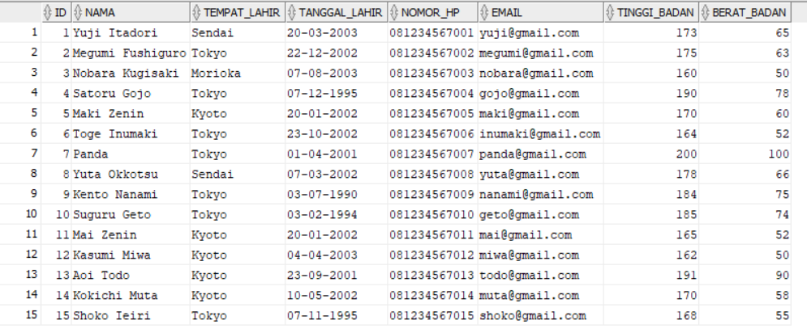

- Lakukan proses pemrosesan satu table untuk fungsi-fungsi berikut:
- Fungsi Karakter dan String (LOWER/UPPER, INITCAP, CONCAT, LENGTH, SUBSTR, LPAD/RPAD, LTRIM, RTRIM, INSTR, REPLACE)
SELECT LOWER(nama) FROM mahasiswa;

SELECT UPPER(nama) FROM mahasiswa;

SELECT INITCAP(nama) FROM mahasiswa;

SELECT CONCAT(nama,email) FROM mahasiswa;

SELECT LENGTH(nama) FROM mahasiswa;

SELECT SUBSTR(nama,1,4) FROM mahasiswa;

SELECT LPAD(nama,20,'*') FROM mahasiswa;

SELECT RPAD(nama,20,'*') FROM mahasiswa;

SELECT LTRIM(' Yuji') FROM dual;

SELECT RTRIM('Gojo ') FROM dual;

SELECT INSTR(email,'@') FROM mahasiswa;

SELECT REPLACE(email,'gmail','jujutsu') FROM mahasiswa;

Screenshots :
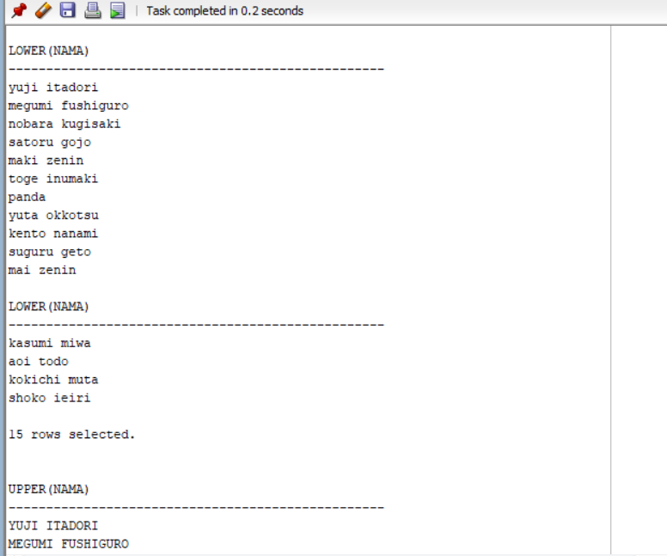
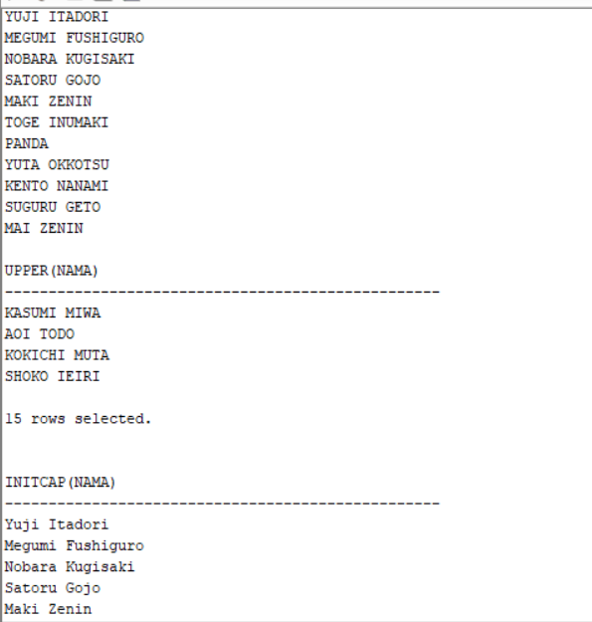
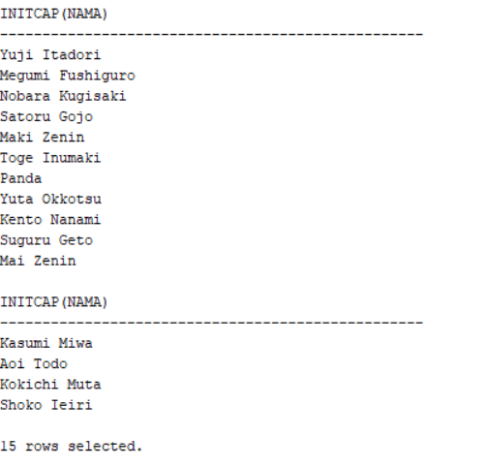
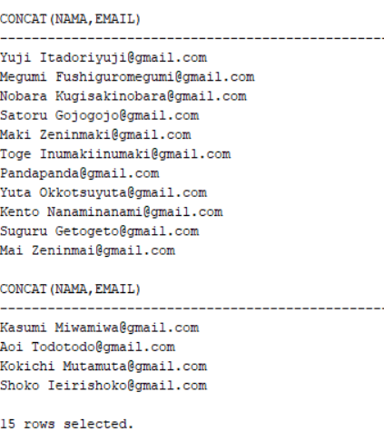
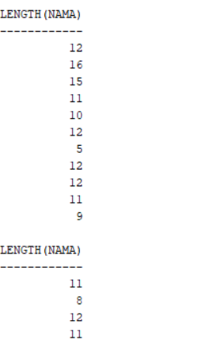

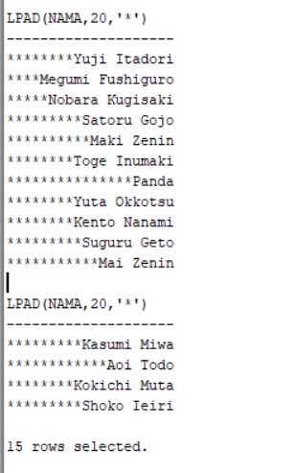
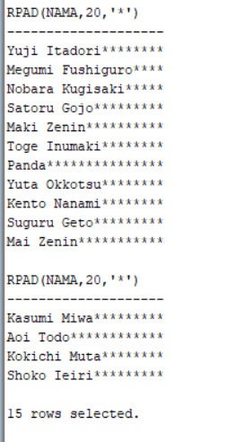
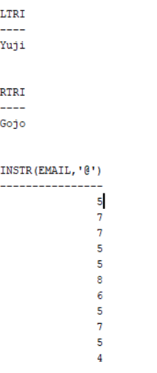
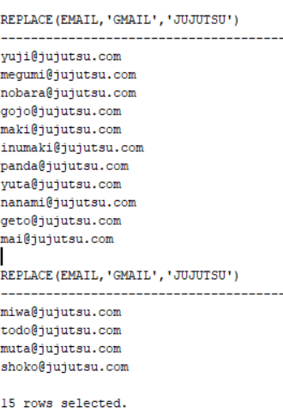
- Fungsi Tanggal dan Waktu (MM/MON/MONTH, DD/DY, YYYY/YY/RR, AM (or PM)/HH/HH24, MI/SS, ADD_MONTHS(d,n), SYSDATE, LAST_DAY(d), NEXT_DAY(d,day_name), MONTHS_BETWEEN(d1,d2), ROUND(d,[MONTH| YEAR]))
SELECT SYSDATE FROM dual;
SELECT ADD_MONTHS(tanggal_lahir,6) FROM mahasiswa;
SELECT LAST_DAY(tanggal_lahir) FROM mahasiswa;
SELECT NEXT_DAY(tanggal_lahir,'MONDAY') FROM mahasiswa;
SELECT MONTHS_BETWEEN(SYSDATE,tanggal_lahir) FROM mahasiswa;
SELECT ROUND(tanggal_lahir,'MONTH') FROM mahasiswa;

SELECT TO_CHAR(tanggal_lahir,'DD MON YYYY') FROM mahasiswa;
SELECT TO_CHAR(tanggal_lahir,'DAY') FROM mahasiswa;
SELECT TO_CHAR(tanggal_lahir,'YYYY') FROM mahasiswa;

Screenshots :
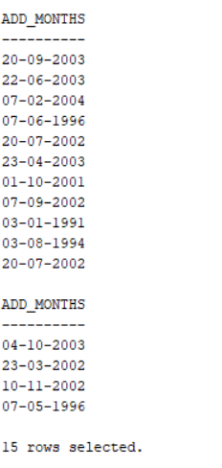
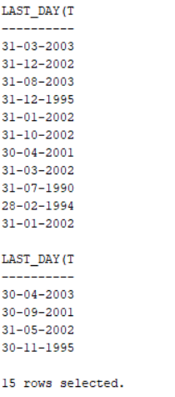
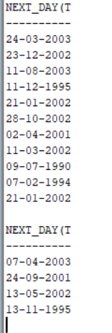
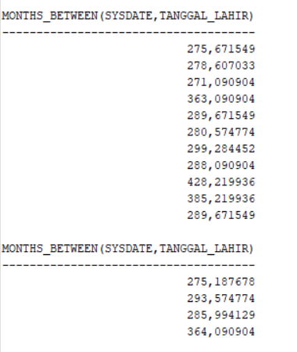
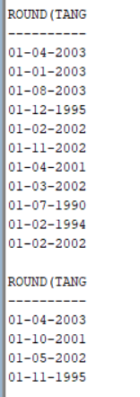
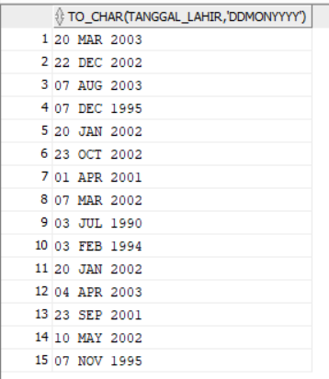
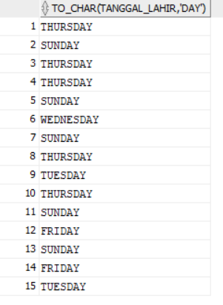
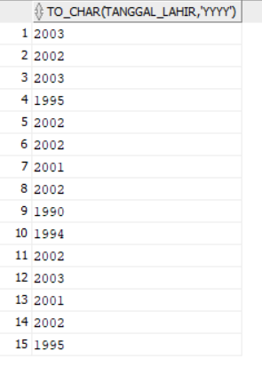
- Fungsi Konversi (TO_NUMBER (char), TO_CHAR (date), TO_CHAR (number), TO_DATE (char))
SELECT TO_NUMBER('123') FROM dual;
SELECT TO_CHAR(tanggal_lahir,'DD-MM-YYYY') FROM mahasiswa;
SELECT TO_CHAR(tinggi_badan) FROM mahasiswa;
SELECT TO_DATE('20-03-2003','DD-MM-YYYY') FROM dual;

Screenshots :
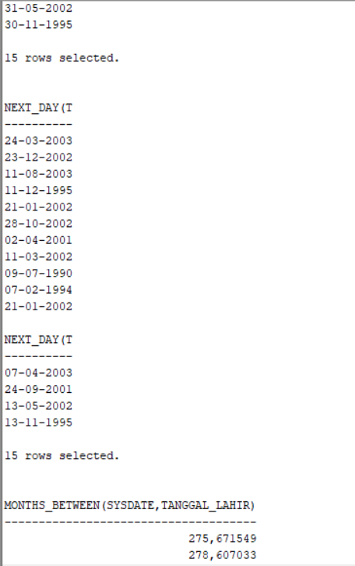
- Fungsi Numerik (ABS(n), MOD (m,n), FLOOR (n), POWER (m,n), ROUND (n[,m]), CEIL (n))
SELECT ABS(-20) FROM dual;
SELECT MOD(15,4) FROM dual;
SELECT FLOOR(12.8) FROM dual;
SELECT POWER(2,4) FROM dual;
SELECT ROUND(15.678,2) FROM dual;
SELECT CEIL(12.2) FROM dual;

Screenshots :
